All subjects begin with a page of demographic information
gender
age
race/ethnicity
highest level of education, self
parents’ education
employment status
occupation
political ideology
marital status
household income
date of birth (for pretest only)

All questions are asked just as they are on the standard TESS questionnaire, except parents’ ed, which is not included on TESS.

Did either of your parents (or the people who raised you) complete a Bachelor’s (BA/BS), graduate (MA/MS/PhD), or professional (MBA, MD, JD) degree? (yes/no)

Next, subjects are sorted into conditions using the logic below. I’m using Qualtrics to field this pre-test, which doesn’t have a true random sorting function.

Condition | 1 | 2 | 3 | 4 | 5 | 6 | 7 | 8 | 9
birth date | 15,9,24,3 | 31,26,2,14 | 10,29,27,30 | 5,6,16,22 | 8,28,4 | 20,18,21 | 23,11,25 | 7,19,12 | 13,17,1

Conditions 1 – 3 are control groups that display each of ten images of paintings, one at a time, and ask for the subject’s opinion about the painting immediately under the image.

Do you like this painting?
No, I do not like it at all.
No, I do not like it very much.
Yes, I like it a little.
Yes, I like it very much.

The final question on each of the control surveys asks the friend question. Each condition considers a different other.
1=low cultural capital: he/she has a high school diploma and has a job in food service.
2=economic specialist: he/she has an MBA and has a job in a financial investment firm
3=cultural specialist: he/she has a PhD and has a job in higher education

A person who has similar demographic characteristics to you has also taken this survey. He/she has a PhD and has a job in higher education (or other description). How likely is it that this is the type of person you would be good friends with?
Very Unlikely
Unlikely
Likely
Very Likely
Conditions 4 – 9 are treatment groups, in which subjects consider an other’s opinion before giving their own. Just under the image of each painting, the subject is told about the other and his/her opinion, and then asked for his/her own opinion.

A person who has some similar demographic characteristics as you has also seen this painting. He/she has a PhD and has a job in higher education (or other description), and likes this painting very much.

Do you like this painting?
No, I do not like it at all.
No, I do not like it very much.
Yes, I like it a little.
Yes, I like it very much.

The other’s opinions are assigned according to the logic below.

 | 4 LCC expected | 5 LCC unexpected | 6 ES expected | 7 ES unexpected | 8 CS expected | 9 CS unexpected
Flax barn | 1 | 4 | 1 | 4 | 4 | 1
Swaying | 4 | 1 | 4 | 1 | 4 | 1
Whirlwind | 1 | 4 | 1 | 4 | 4 | 1
Franzi | 1 | 4 | 1 | 4 | 4 | 1
Grove | 4 | 1 | 4 | 1 | 4 | 1
Woman | 4 | 1 | 4 | 1 | 4 | 1
Chateau | 1 | 4 | 1 | 4 | 4 | 1
Monk | 1 | 4 | 4 | 1 | 4 | 1
Les Vessenots | 1 | 4 | 4 | 1 | 4 | 1
Nocturne | 1 | 4 | 1 | 4 | 4 | 1
1 = I do not like it at all; 4 = I like it very much

Images will be shown in this order (which was randomly selected) in every condition. To hold style somewhat constant, all selected paintings are from western (European or American) artists, from the 19th or early 20th century (1808 – 1910).

Others’ opinions were assigned according to what we know about class differences in taste. Cultural specialists will like everything; LCCs will only like realistic and happy images that require no interpretation, while economic specialists will recognize and therefore like paintings by well-known artists (such as Swaying – Degas, Woman – Renoir, Les Vessnots – van Gogh) and will not like paintings that look “too artsy” (such as Whirlwind, Franzi, Chateau and Nocturne) or gloomy/mundane (such as Flax barn). Certainly these assignments are arbitrary, and the class-based nature of taste in any of these pictures is an empirical question that I hope this pretest will answer. Therefore, these assignments might change for the actual survey.

The final two questions on the treatment surveys ask the friend question and check validity.

You have been considering the opinions of a person who has seen the same paintings that you have. He/she has a PhD and has a job in higher education (or other description).

How likely is it that he/she is the type of person you would be good friends with?
Very Unlikely
Unlikely
Likely
Very Likely

Given what you had been told about this other person, did his/her opinions about the paintings make sense to you?
Yes, the opinions made sense to me.
No, the opinions surprised me.
I’m unsure; some opinions made sense, others were surprising.
I’m neutral; the other person’s opinions seemed neither surprising nor unsurprising.

Flax Barn (The Flax Barn at Laren, Max Libermann, 1987, German)
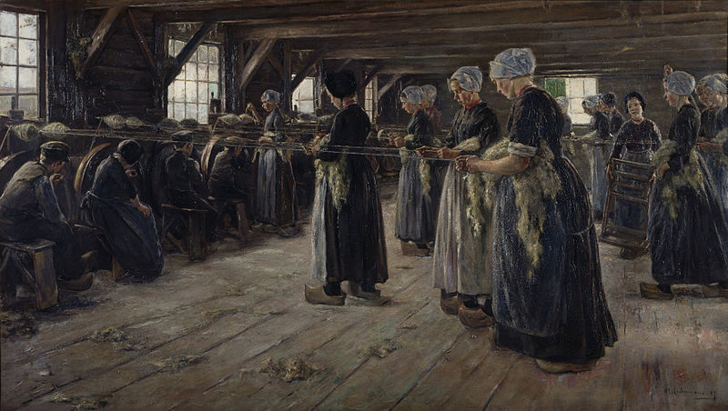

Swaying (Swaying Dancer, Edgar Degas, 1877, French)
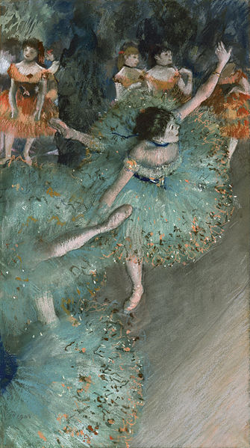

Whirlwind (Whirlwind, Filipp Malyavin, 1906, Russian)
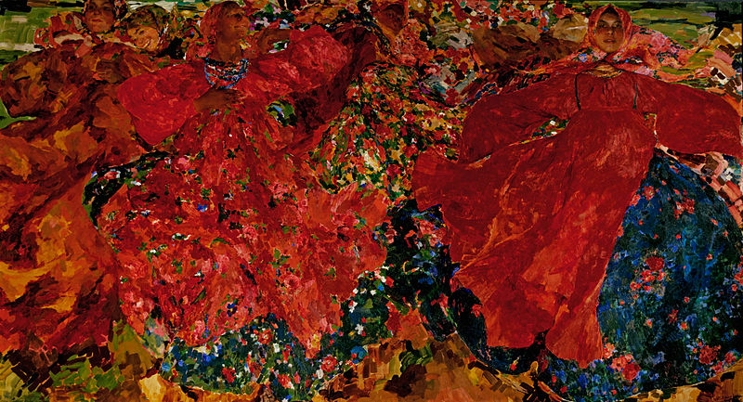

Franzi (Franzi in front of Carved Chair, Ernst Ludwig Kirchner, 1910, German)


Grove (The Grove, John Constable, 1821, English)
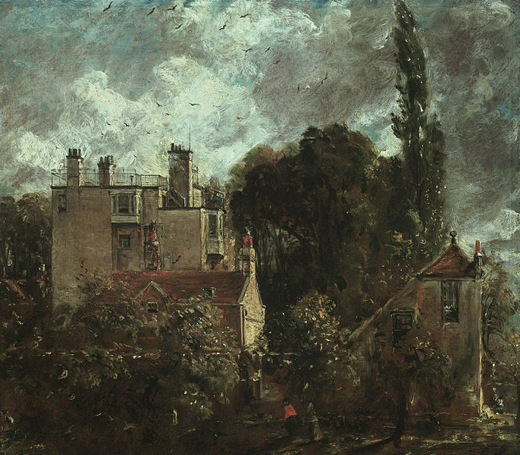

Woman (Woman with a Parasol in a Garden, Renoir, 1875, French)
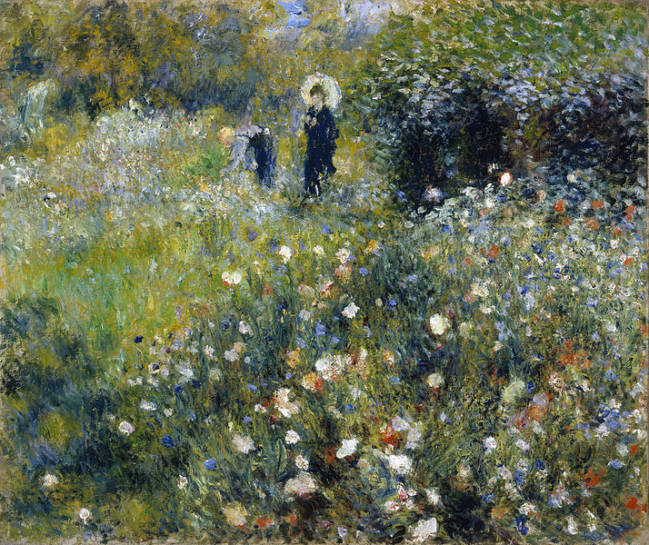

Chateau (Chateau Noir, Paul Cezanne, 1903, French)
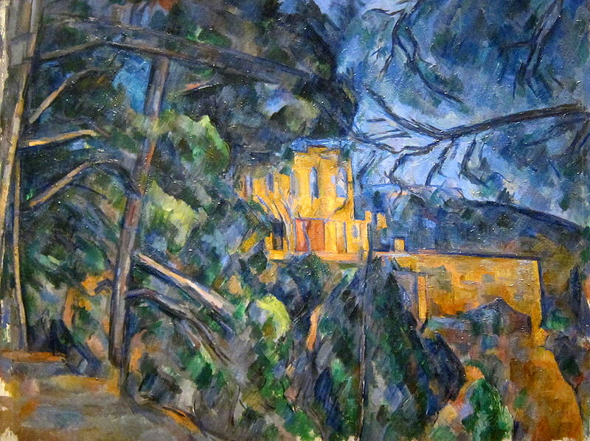

Monk (Monk by the Sea, Caspar David Friedrich, 1809, German)
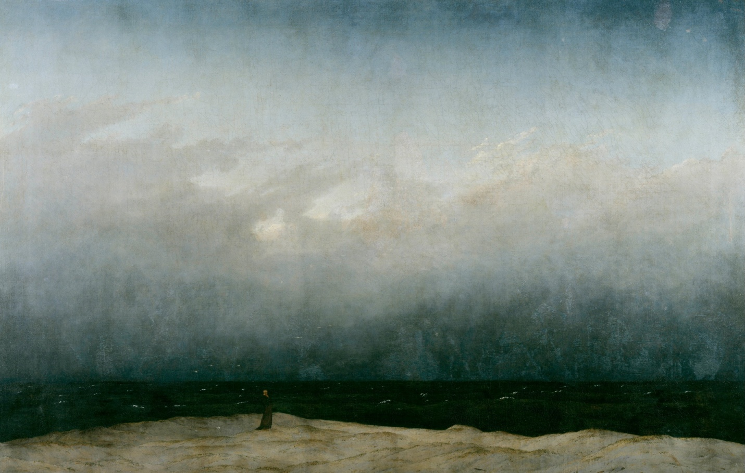

Les Vessenots (Les vessenots a Auvers, van Gogh, 1890, Dutch)
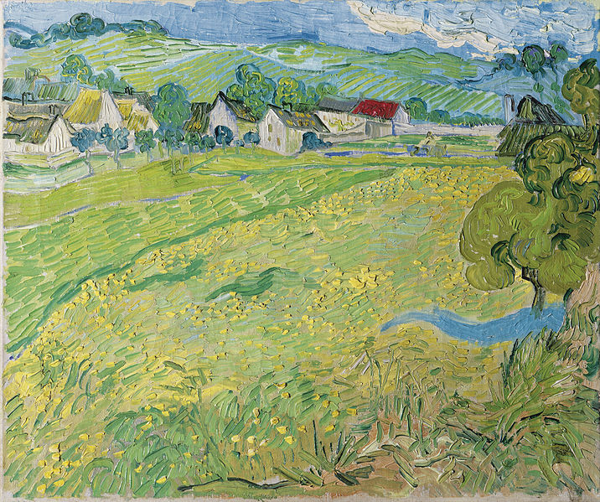

Nocturne (Nocturne: Battersea Bridge, James Whistler, 1872, American/British)
